**Table of contents**

* 1. Requirement Analysis ………………………………………………1  
     1.2 Use Case Diagram Components……………………………………..2  
     1.3 Example of Use Case Model…………………………………………2  
     1.4 Use Case Description/Template………………………………………3  
     1.5 Tools and Steps to Draw Use Case Diagram………………………….4

CHAPTER ONE

1.1 REQUIREMENT ANALYSIS

**Requirement Analysis-** The process of studying and analyzing the customer and the user need to arrive at the definition of the problem domain and system requirements.

In the context of an ONLINE FOOD AND DELIVERY SYSTEM, Requirement Analysis invloves understanding what function the system must perform and how the user will interact with it.

The Food Ordering System Online is an efficient and user-friendly platform that allows customers to order food from restaurants in a hassle-free manner. The system offers a range of features, including the ability to search for restaurants, view menus, place orders, make payments, and receive orders.

These are all about the interaction of the system and the user which we call **USE CASE.**

**Functional Requirement**

* User must be able to register and login.
* Restaurants must be able to list menu item.
* Users/customers can place orders.
* The system must support payment processing.
* Restaurants Receive and confirm orders.
* Delivery personel are notified for confirmed orders.
* Users can tract their orders.

**Now lets discuss how all of these functional requirement are implemented on our platform(website)**

The first step in the system is to search for restaurants. Customers can search for restaurants by location, cuisine, or rating, allowing them to find the perfect restaurant for their needs.

Once customers have found a restaurant they like, they can view the menu and select the dishes they want to order. The system displays the menu in an organized and easy-to-navigate format, with images and descriptions of each dish.

Customers can select the items they want, specify any special requests or dietary restrictions, and add the items to their cart. This feature ensures that customers can order exactly what they want and helps to reduce errors and misunderstandings.

After the order has been placed, customers can make payments using a secure payment gateway. The system supports multiple payment options, including credit cards, debit cards, and online wallets, making it easy for customers to pay for their orders. Once the payment is confirmed, the order is processed, and the restaurant is notified. The restaurant begins to prepare the order, and the customer receives notifications about the status of their order, including estimated delivery time and preparation time.

Finally, when the order is ready, the system notifies the customer, and they can receive their food. The system ensures that the order is accurate and complete, and provides a seamless experience for both customers and restaurants. Additionally, the system supports inventory management and payment processing, allowing restaurants to manage their inventory and payments in a centralized and efficient manner. This feature streamlines the restaurant's operations and ensures that they can provide high-quality service to their customers.

1.2 Use Case Diagram Components

A **Use case Diagram** is a visual representation of the interaction between the system and the user(actors).

**The main components are:**

**Actors:** represent the users or external systems interacting with The internal system(e.g customer, restaurant,delivery person).

**Use cases:**  Represent system functionality to users(e.g place order, make payment).

**System boundary:** Define the scope of the system.

**Relationships:** The relation between the system and actors especially Association

1.3 Example of use case model2

Below is a textual represntation of a use case model for an **Online Food Delivery System:**

**Actors:**

* Customer
* Restaurant admin
* Delivery person
* System Admin
* Delivery person

**Use case:**

* Register/login
* Search restaurant
* Browse menu
* Place order
* Make payment
* Confirm Order Status
* Update Menu
* Receive Order
* Prepare Oreder
* Notify Customer
* Process order
* Mange inventory
* Logout
* Recieve Notification

According to those representation above, Here is our use case diagram

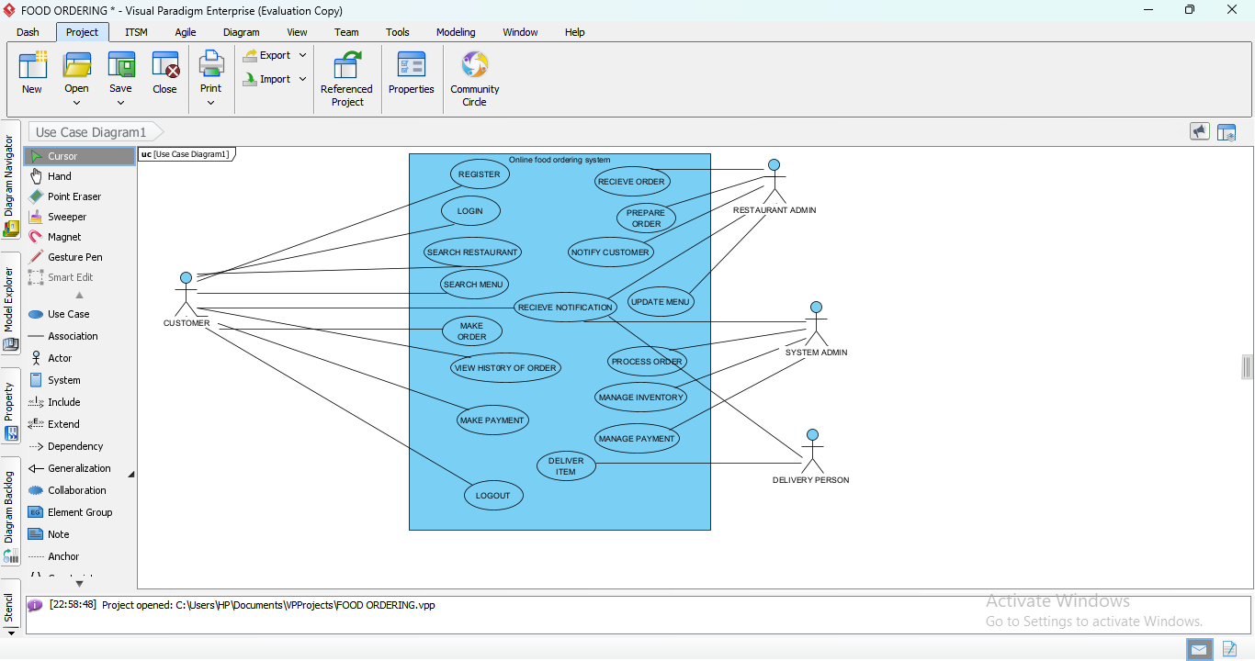

Fig 1.1 Use case Diagram

1.4 Use Case Despcription/Template

A **Use case Description** provides detailed information about each use case.

* Below is the standard template with an example

**Use case Template Example-Place Order**

|  |  |  |
| --- | --- | --- |
| **Use case Name** | **Place Order** |  |
| **Actors** | Customer |  |
| **Description** | This use case describes how customer places a food order from a restaurant using the platform |  |
| **Precondition** | The customer must be logged in and have selected item from the menu. |  |
| **Postcondition** | The order is saved in the system and sent to the restaurant. |  |
| **Main flow** | -Customer Selects items and add to cart.  -Customer proceeds to checkout.  -Customer contfirms address and payment method.  -System saves the order and notifies the restaurant. |  |
| **Alternatives Flows**  **Exceptions**- | - If the Payment fails, the order is not confirmed.  - Network failure, payment gatway timeout. |  |

1.5 Tools and Steps to Draw Use Case Diagram for Online Food Delivery System

Tools:

There are Differents tools to draw use case diagram like:

* Lucidchart
* Draw.io(diagrams.set)
* StarUML
* Visual paradigm
* Microsoft Visio

But the best one I’m using for Online Food and Delivery system is Visual paradigm.

Step to Draw Use Case Diagram

1. Identify the system boundary: Define what’s inside and outside the system.
2. Identify the actors: Determine all users and Systems interacting with the system.

On the figure below is all about Actors(users) interacting with our system.

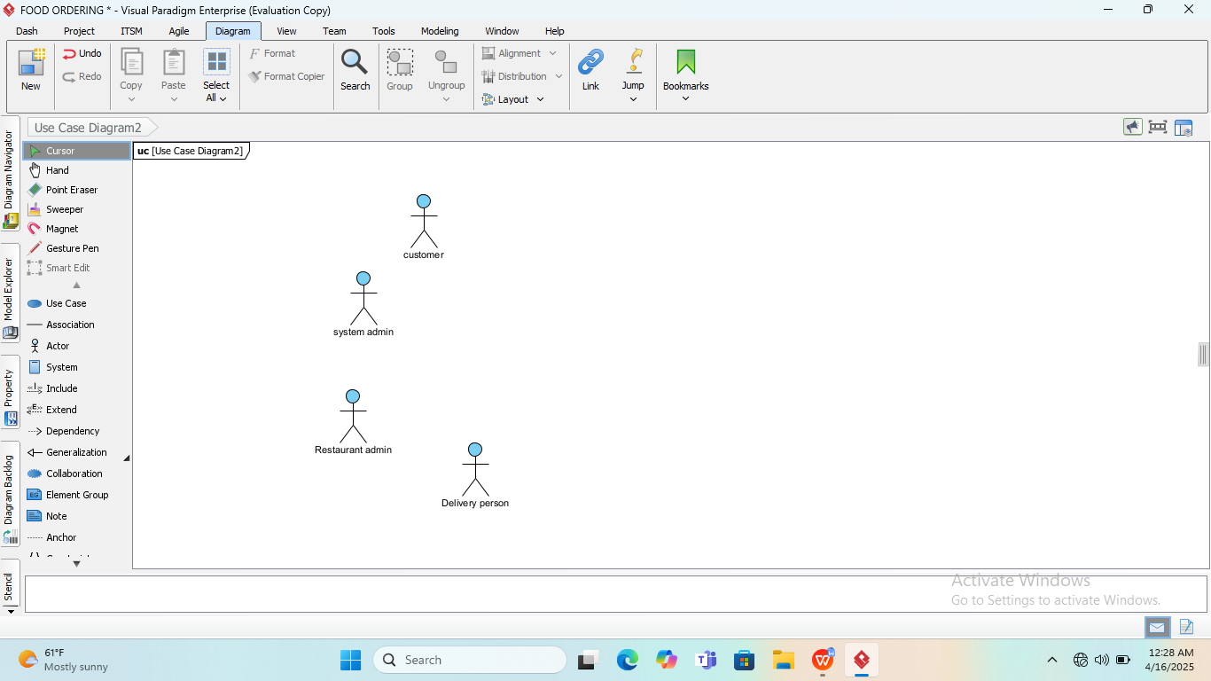

Fig 1.2 actors in Online food delivery

1. Identify Use Cases: Define the functionalties the system should provide.

This image is our identification of use cases :

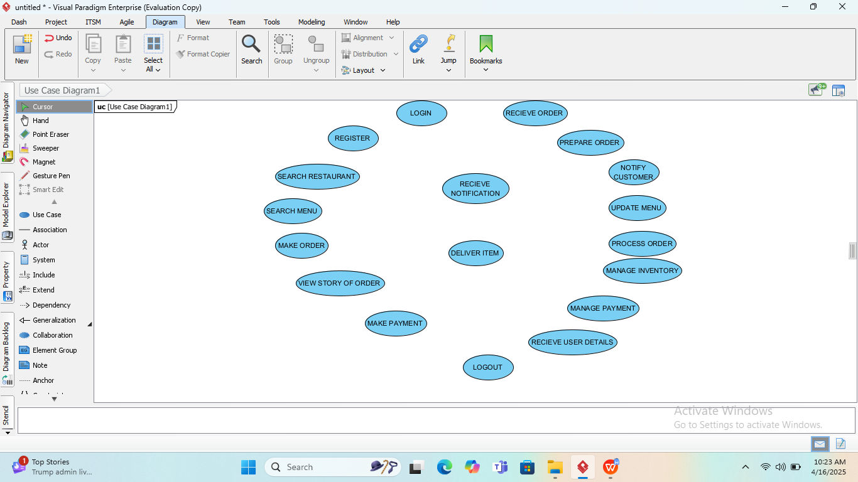

Fig 1.3 use cases identification.

1. Draw the actors outside the system boundary.

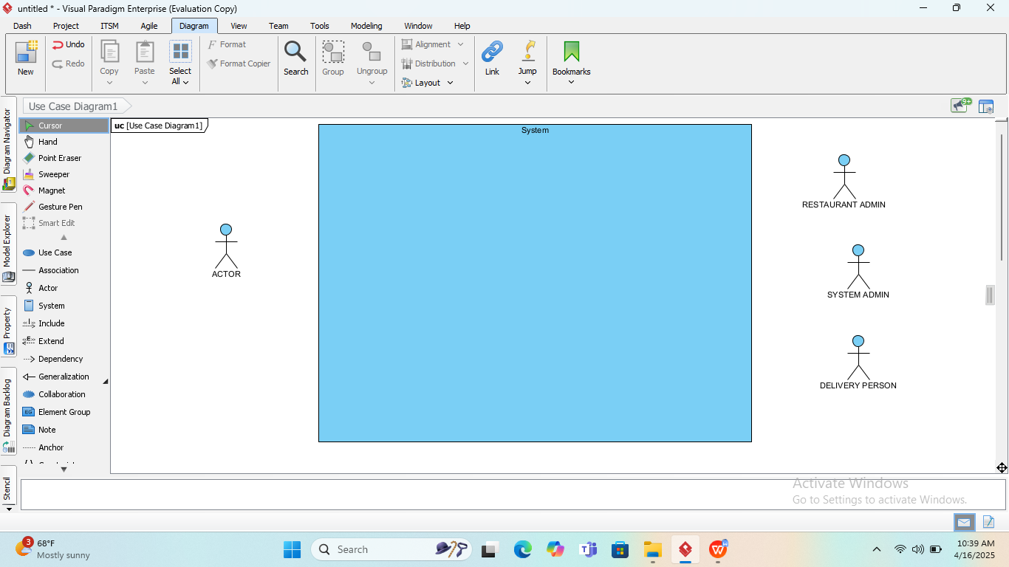

Fig 1.4 Actors ouside system boundary

1. Draw the use cases inside the system boundary.

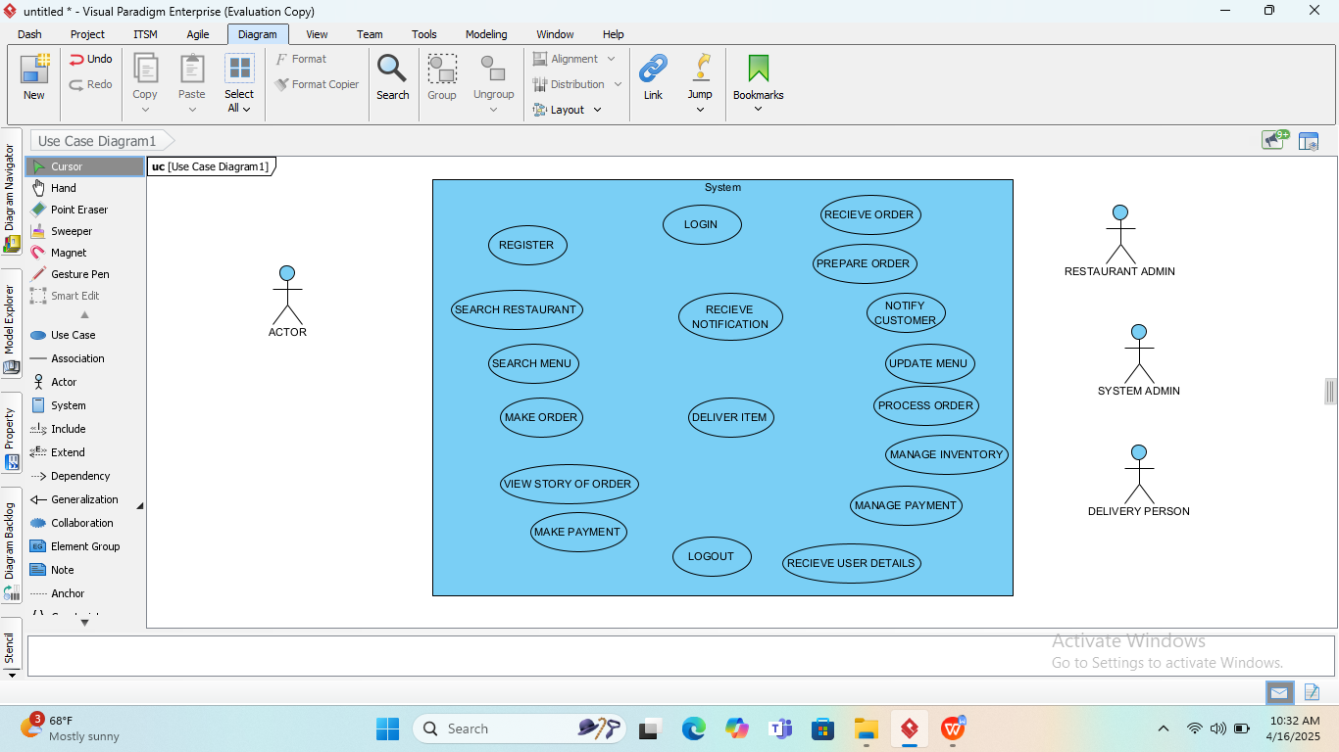

Fig1.5 use cases inside the system boundary

6.Connect the actors and the Use Cases using associations relation.

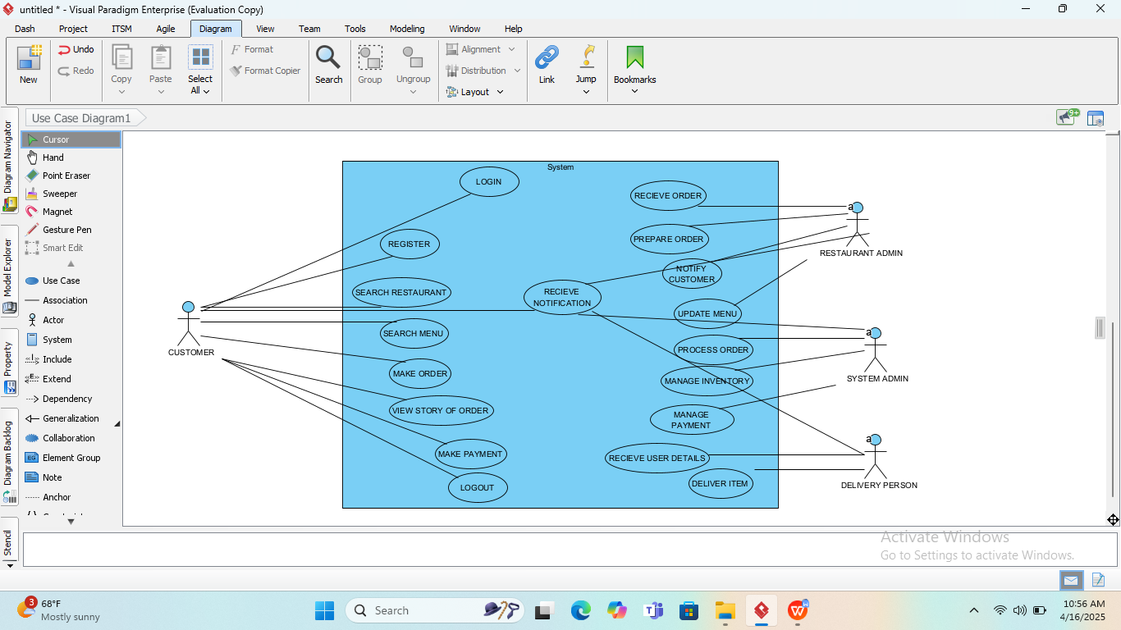

Fig 1.6 connection of actors and use cases.

7.Label all components clealy and review for completeness.

According to all of those steps one by one I draw the Use Case of ONLINE FOOD ORDERING AND DELIVERY in visual paradigm. So here is the outcome of Diagram:

The outcome of Steps to draw Use Case Diagram

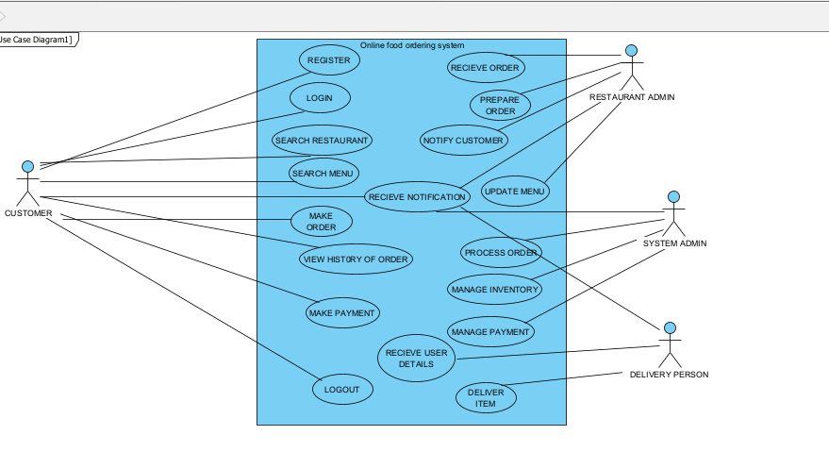

Fig 1.7 Use Case Diagram